**CTEC 3350  
Web Communication Design and Development 2**

**Flexbox – justify-content: \***

Screenshot 1

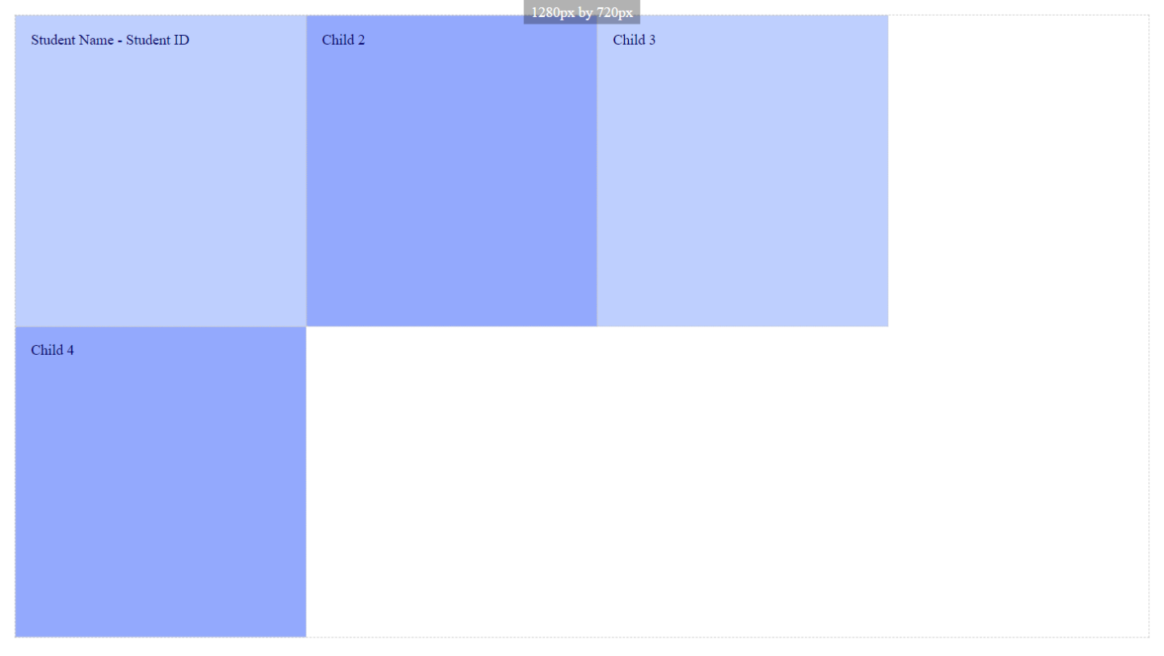

Paste a copy of your screenshot including your Student Name and Student ID (here)

Paste the style declaration you used to make your screenshot happen.

display:   
flex-flow:  
justify-content:

Screenshot 2

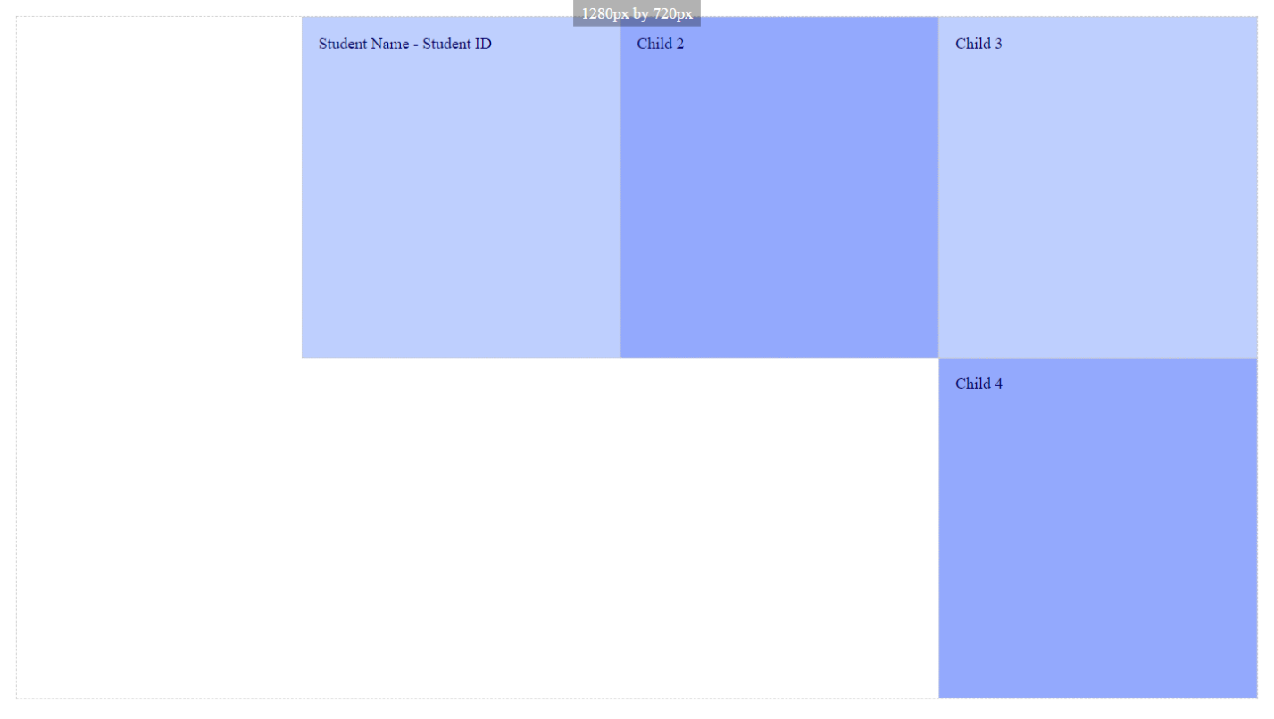

Paste a copy of your screenshot including your Student Name and Student ID (here)

Paste the style declaration you used to make your screenshot happen.

display:   
flex-flow:  
justify-content:

Screenshot 3

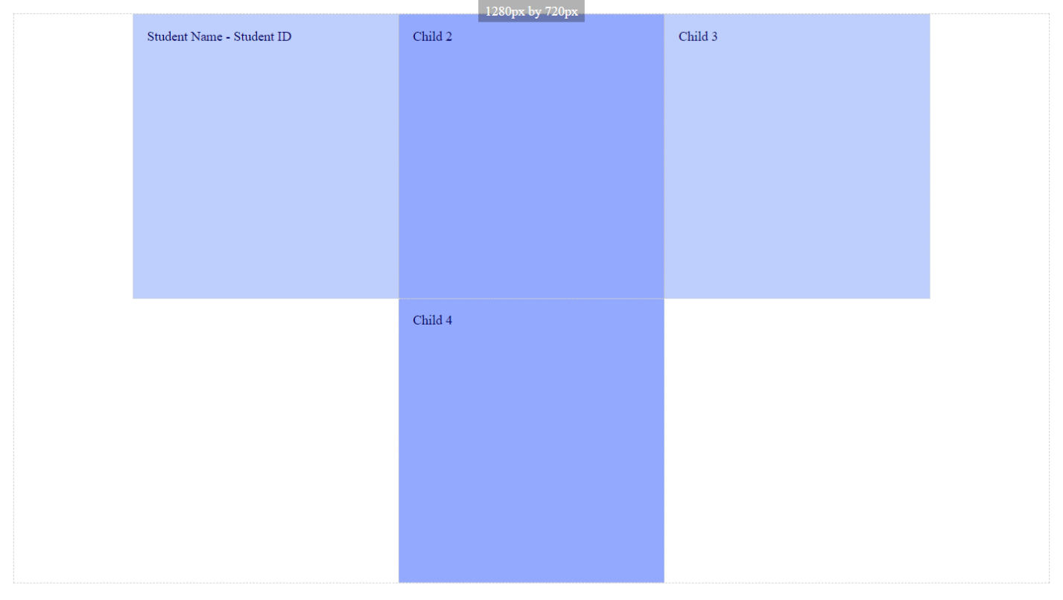

Paste a copy of your screenshot including your Student Name and Student ID (here)

Paste the style declaration you used to make your screenshot happen.

display:   
flex-flow:  
justify-content:

Screenshot 4

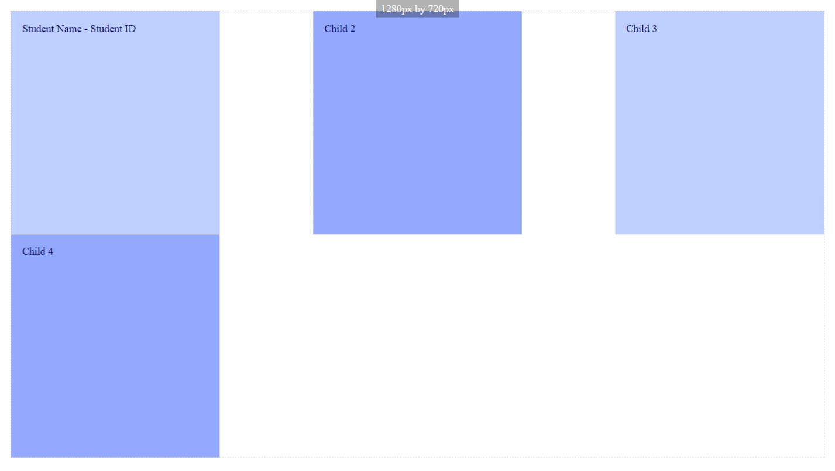

Paste a copy of your screenshot including your Student Name and Student ID (here)

Paste the style declaration you used to make your screenshot happen.

display:   
flex-flow:  
justify-content:

Screenshot 5

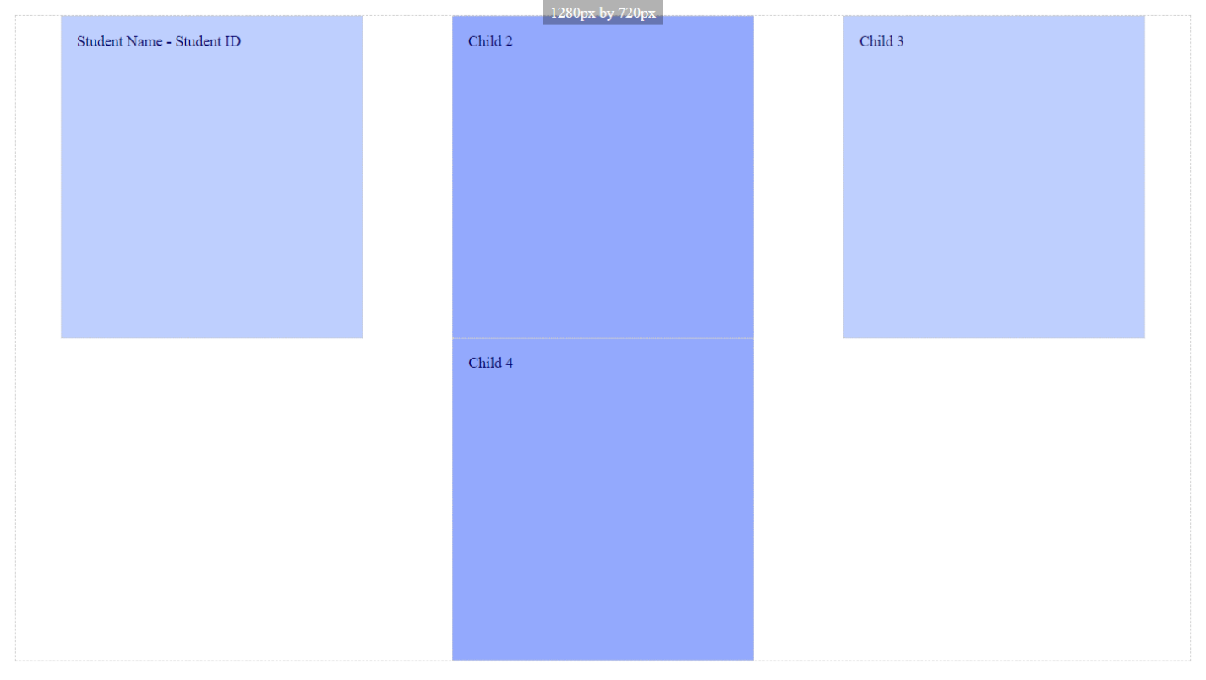

Paste a copy of your screenshot including your Student Name and Student ID (here)

Paste the style declaration you used to make your screenshot happen.

display:   
flex-flow:  
justify-content:

Screenshot 6

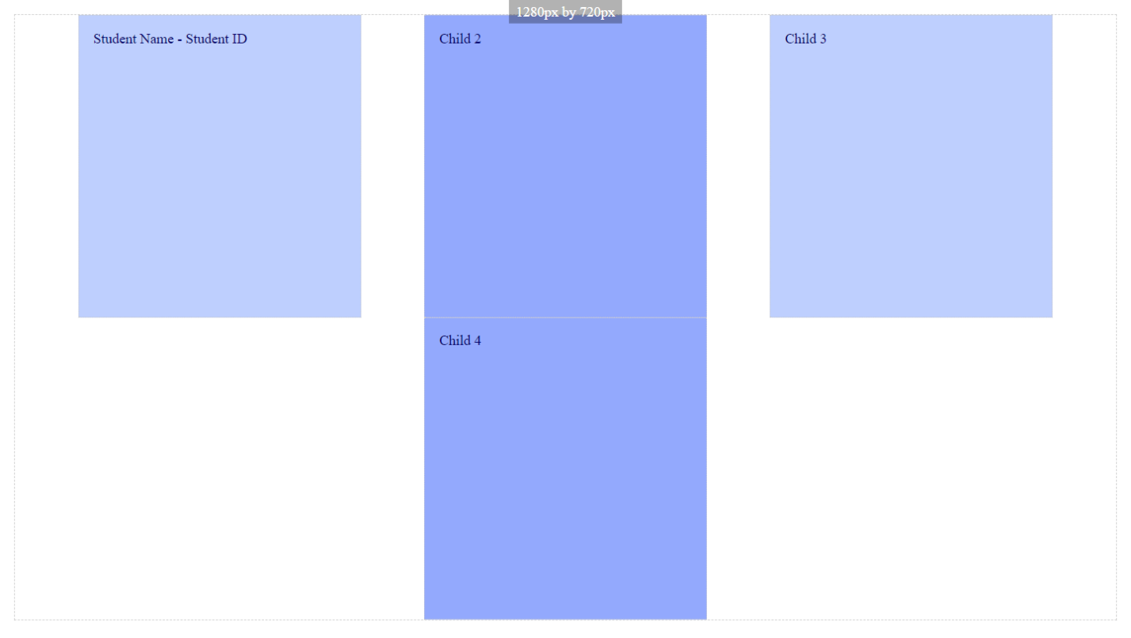

Paste a copy of your screenshot including your Student Name and Student ID (here)

Paste the style declaration you used to make your screenshot happen.

display:   
flex-flow:  
justify-content:

Screenshot 7

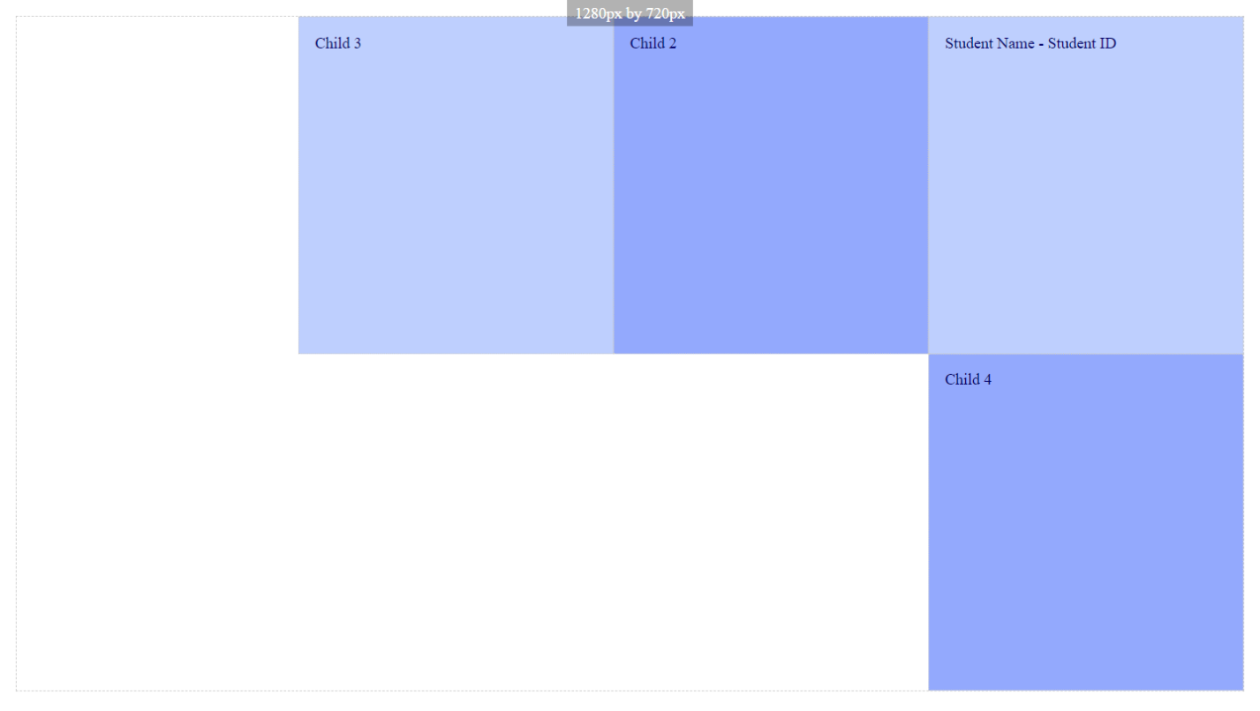

Paste a copy of your screenshot including your Student Name and Student ID (here)

Paste the style declaration you used to make your screenshot happen.

display:   
flex-flow:  
justify-content:

Screenshot 8

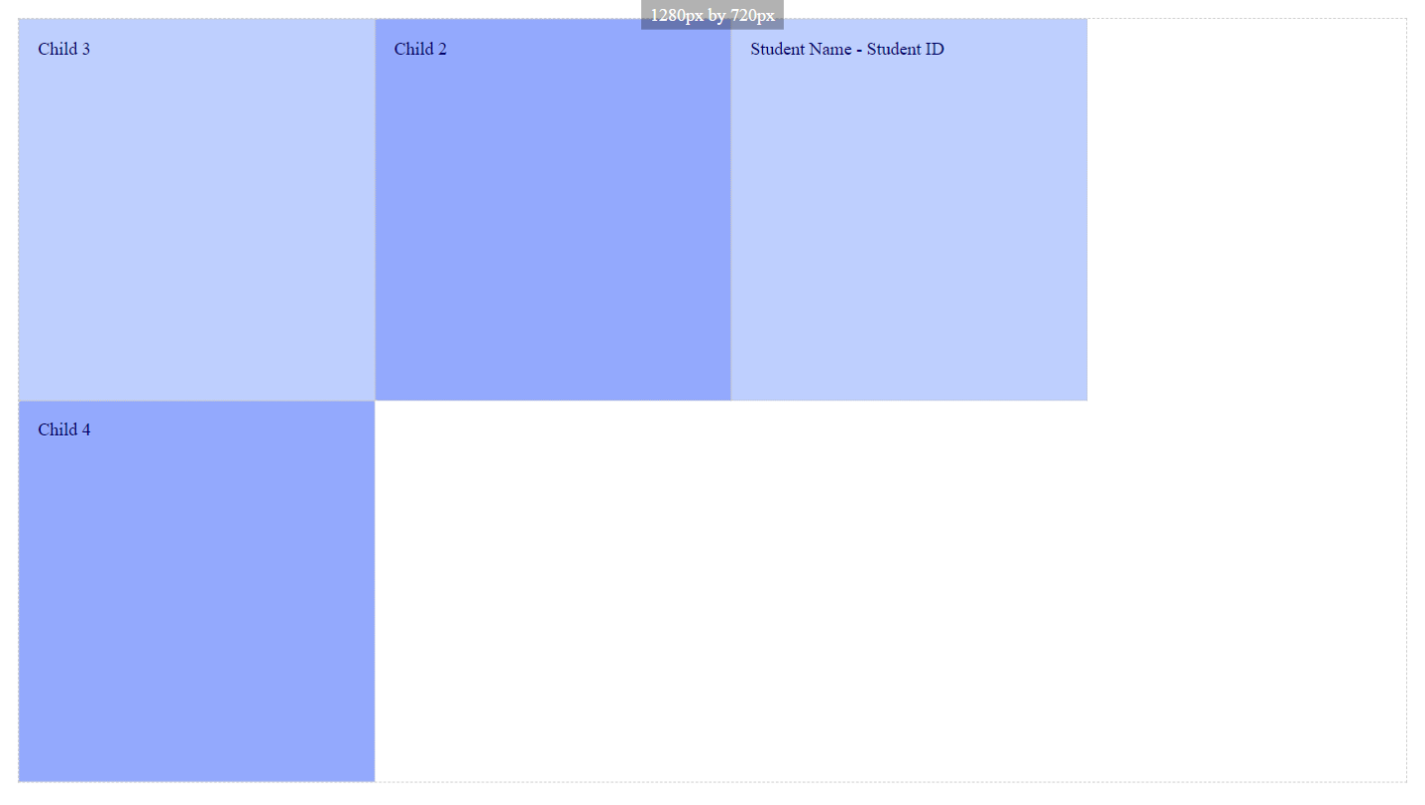

Paste a copy of your screenshot including your Student Name and Student ID (here)

Paste the style declaration you used to make your screenshot happen.

display:   
flex-flow:  
justify-content:

Screenshot 9

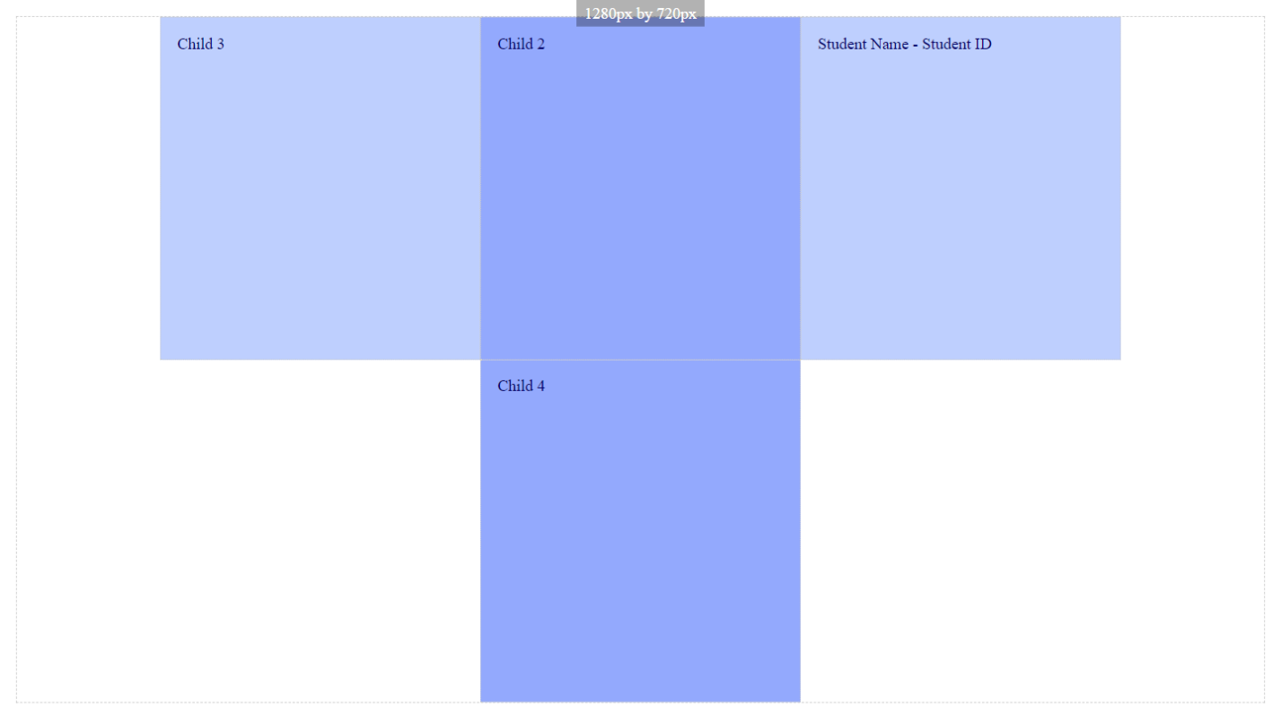

Paste a copy of your screenshot including your Student Name and Student ID (here)

Paste the style declaration you used to make your screenshot happen.

display:   
flex-flow:  
justify-content:

Screenshot 10

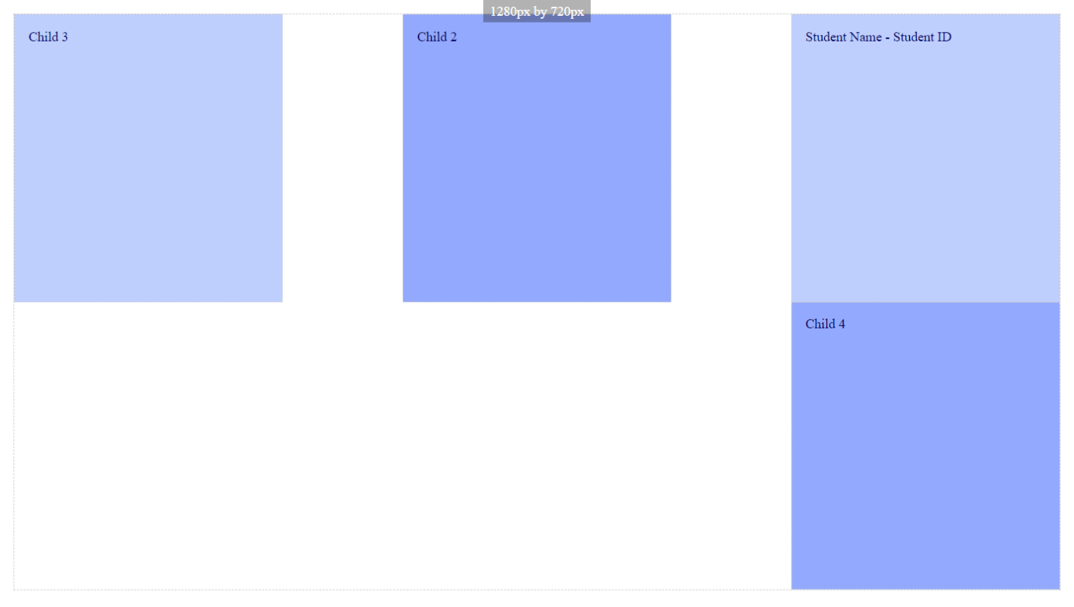

Paste a copy of your screenshot including your Student Name and Student ID (here)

Paste the style declaration you used to make your screenshot happen.

display:   
flex-flow:  
justify-content:

Screenshot 11

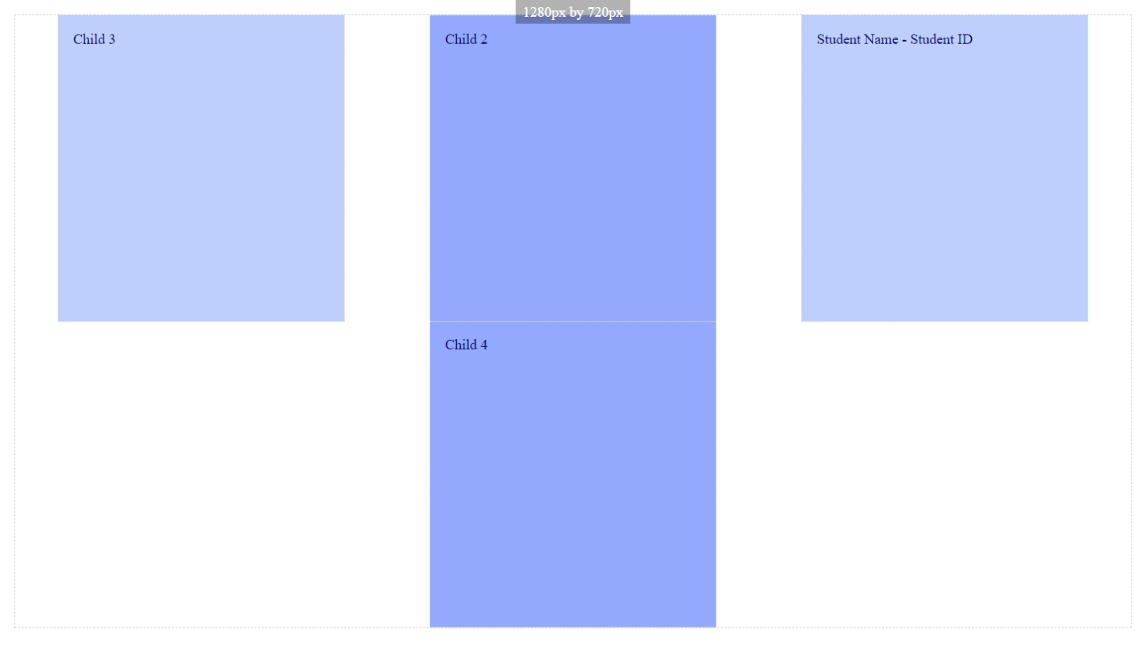

Paste a copy of your screenshot including your Student Name and Student ID (here)

Paste the style declaration you used to make your screenshot happen.

display:   
flex-flow:  
justify-content:

Screenshot 12

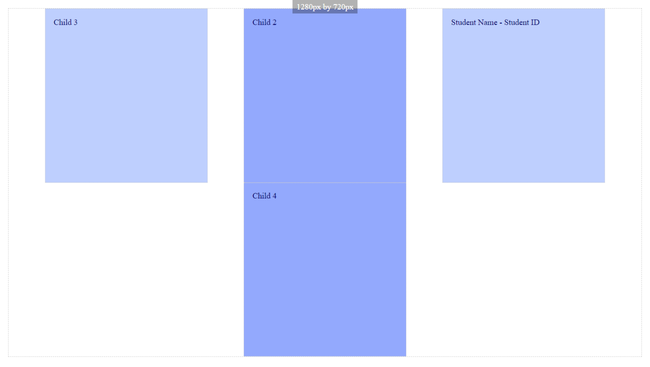

Paste a copy of your screenshot including your Student Name and Student ID (here)

Paste the style declaration you used to make your screenshot happen.

display:   
flex-flow:  
justify-content:

Screenshot 13

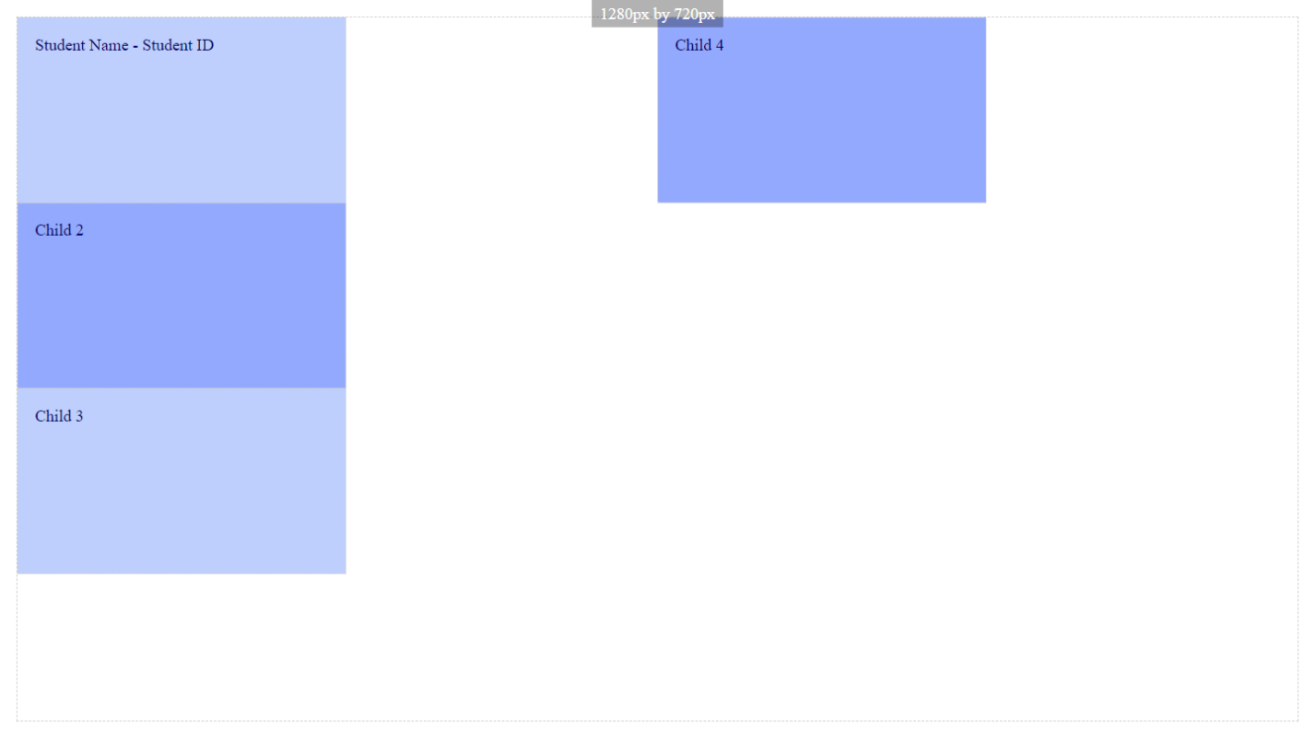

Paste a copy of your screenshot including your Student Name and Student ID (here)

Paste the style declaration you used to make your screenshot happen.

display:   
flex-flow:  
justify-content:

Screenshot 14

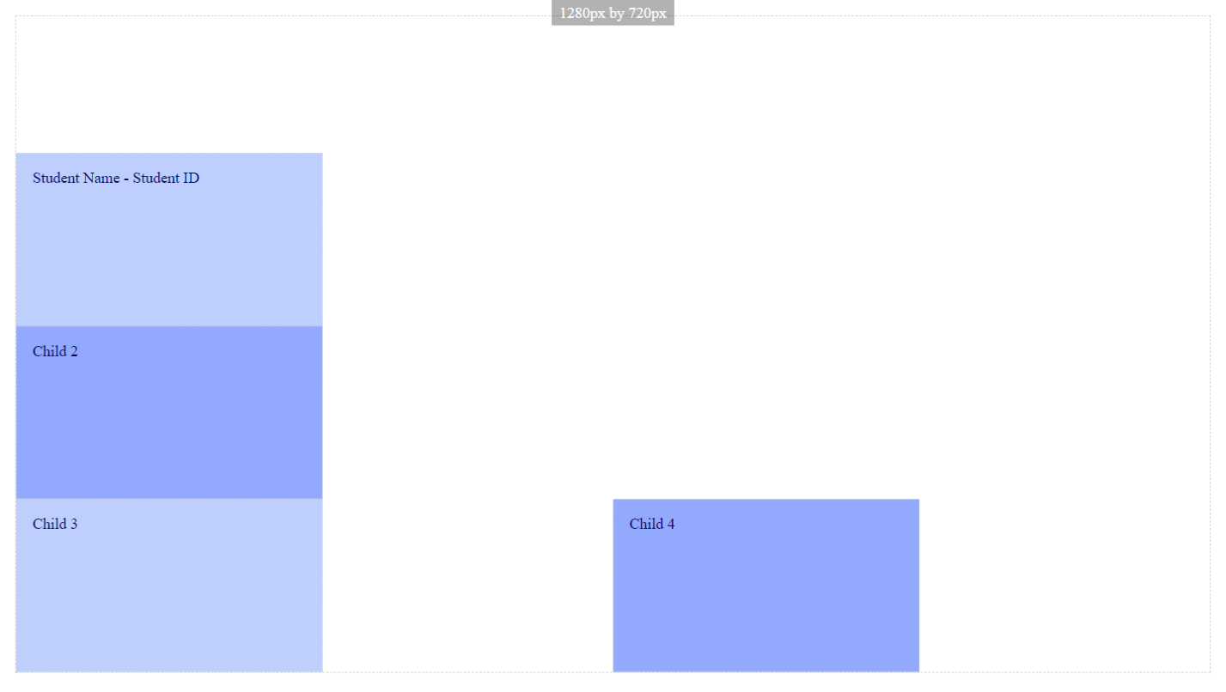

Paste a copy of your screenshot including your Student Name and Student ID (here)

Paste the style declaration you used to make your screenshot happen.

display:   
flex-flow:  
justify-content:

Screenshot 15

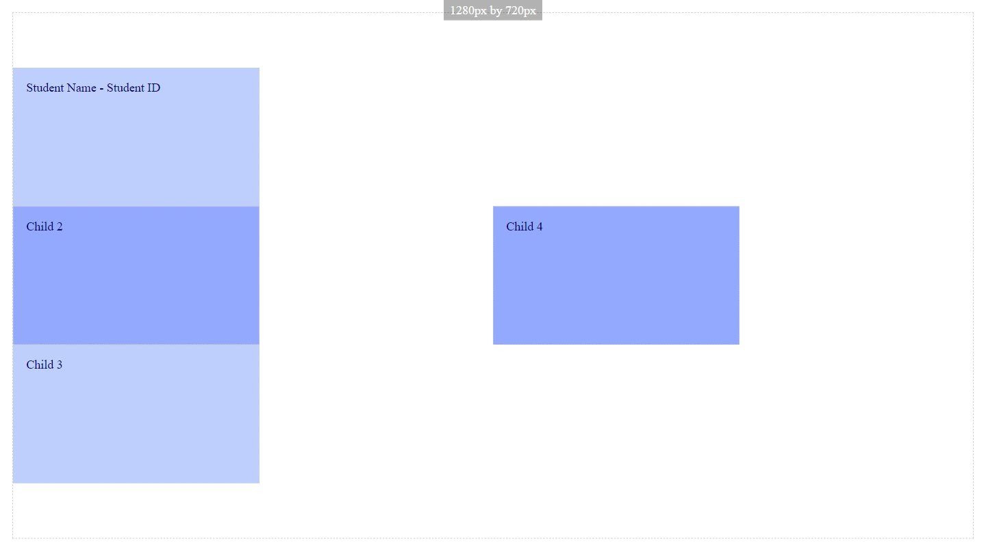

Paste a copy of your screenshot including your Student Name and Student ID (here)

Paste the style declaration you used to make your screenshot happen.

display:   
flex-flow:  
justify-content:

Screenshot 16

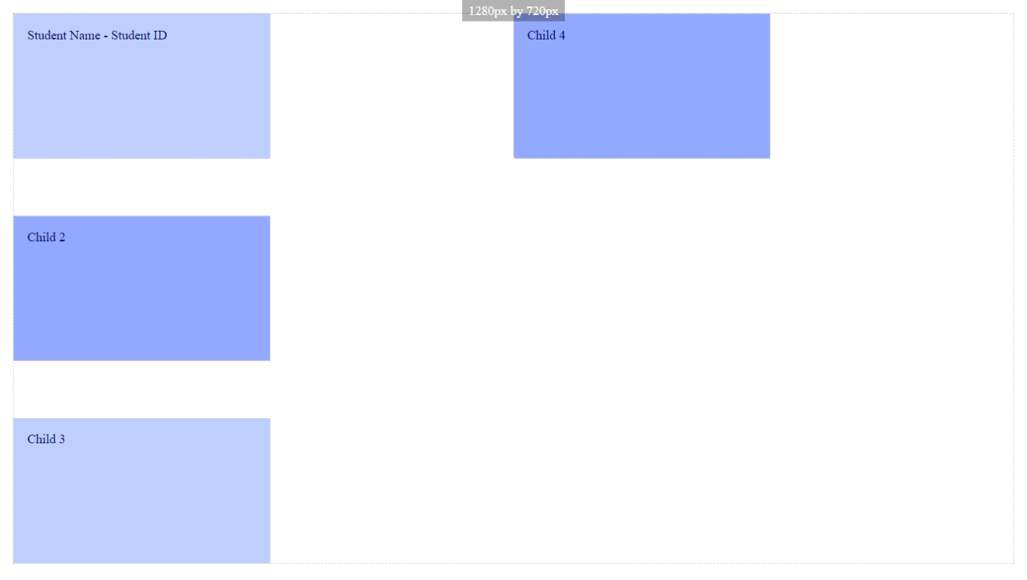

Paste a copy of your screenshot including your Student Name and Student ID (here)

Paste the style declaration you used to make your screenshot happen.

display:   
flex-flow:  
justify-content:

Screenshot 17

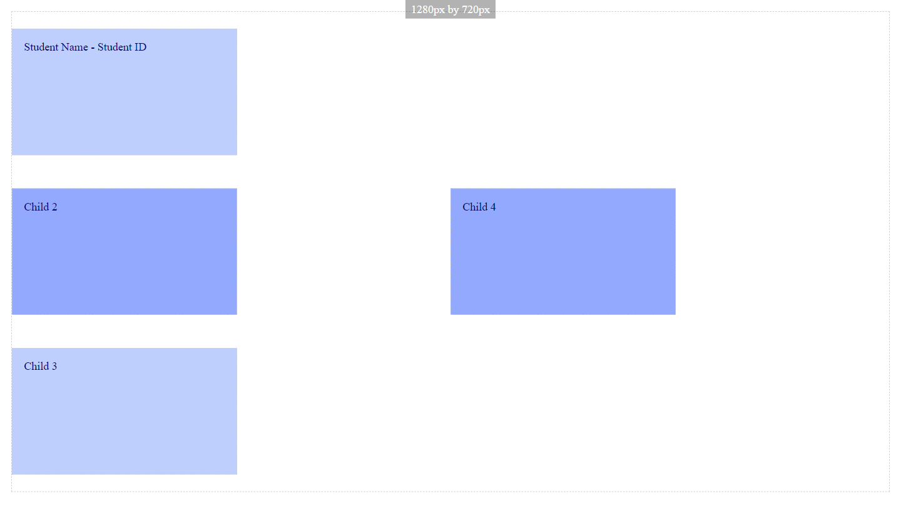

Paste a copy of your screenshot including your Student Name and Student ID (here)

Paste the style declaration you used to make your screenshot happen.

display:   
flex-flow:  
justify-content:

Screenshot 18

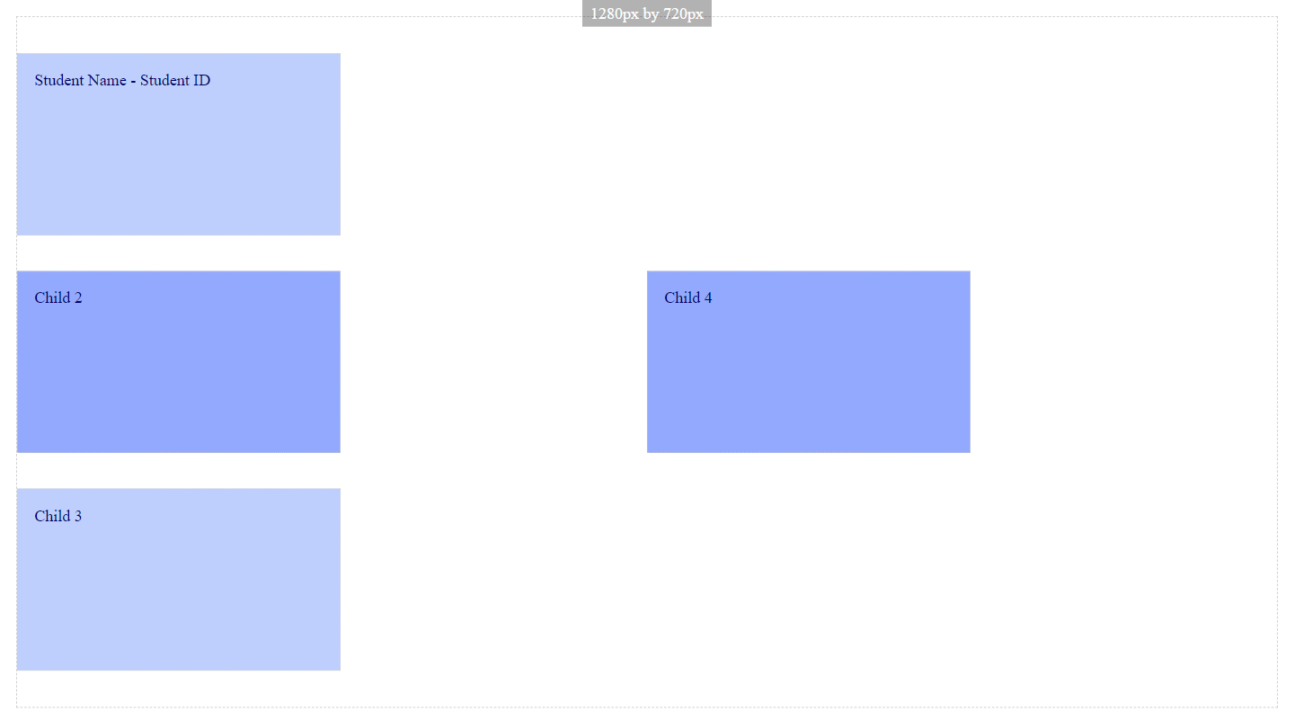

Paste a copy of your screenshot including your Student Name and Student ID (here)

Paste the style declaration you used to make your screenshot happen.

display:   
flex-flow:  
justify-content:

Screenshot 19

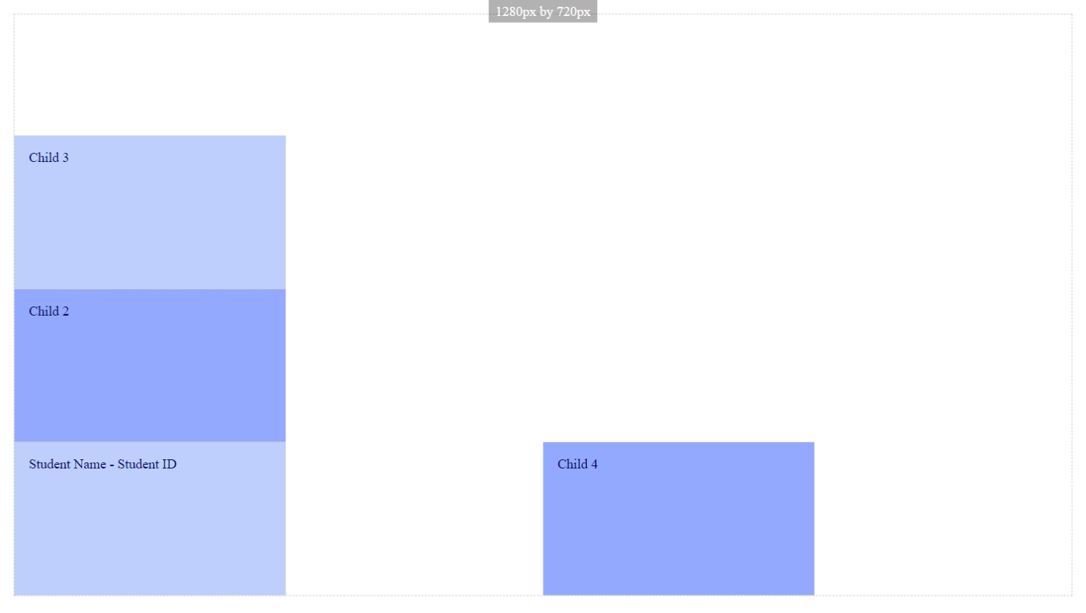

Paste a copy of your screenshot including your Student Name and Student ID (here)

Paste the style declaration you used to make your screenshot happen.

display:   
flex-flow:  
justify-content:

Screenshot 20

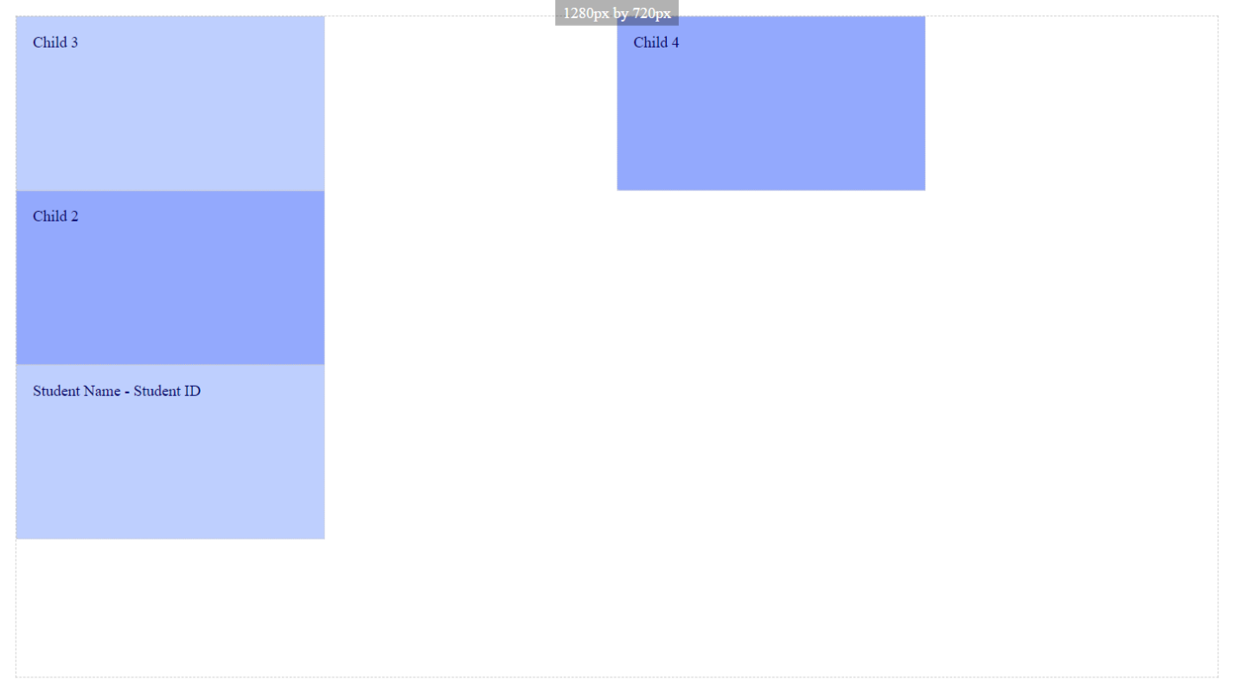

Paste a copy of your screenshot including your Student Name and Student ID (here)

Paste the style declaration you used to make your screenshot happen.

display:   
flex-flow:  
justify-content:

Screenshot 21

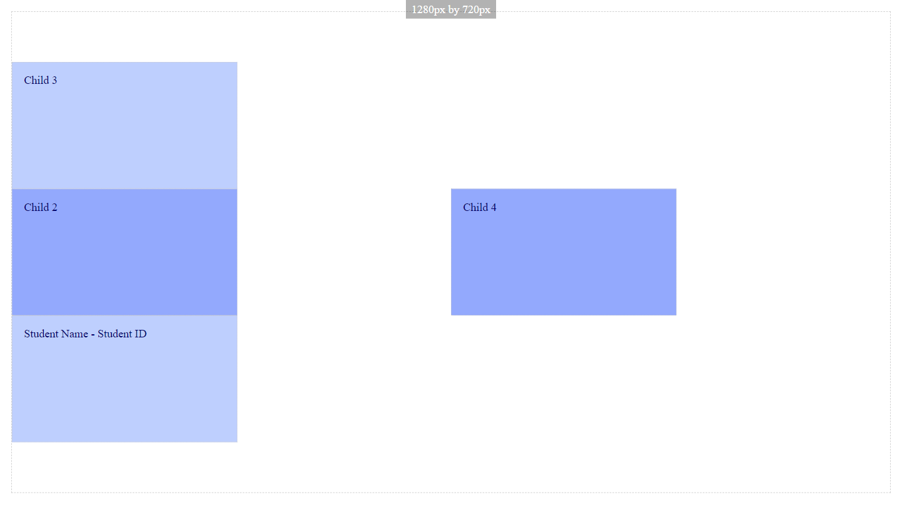

Paste a copy of your screenshot including your Student Name and Student ID (here)

Paste the style declaration you used to make your screenshot happen.

display:   
flex-flow:  
justify-content:

Screenshot 22

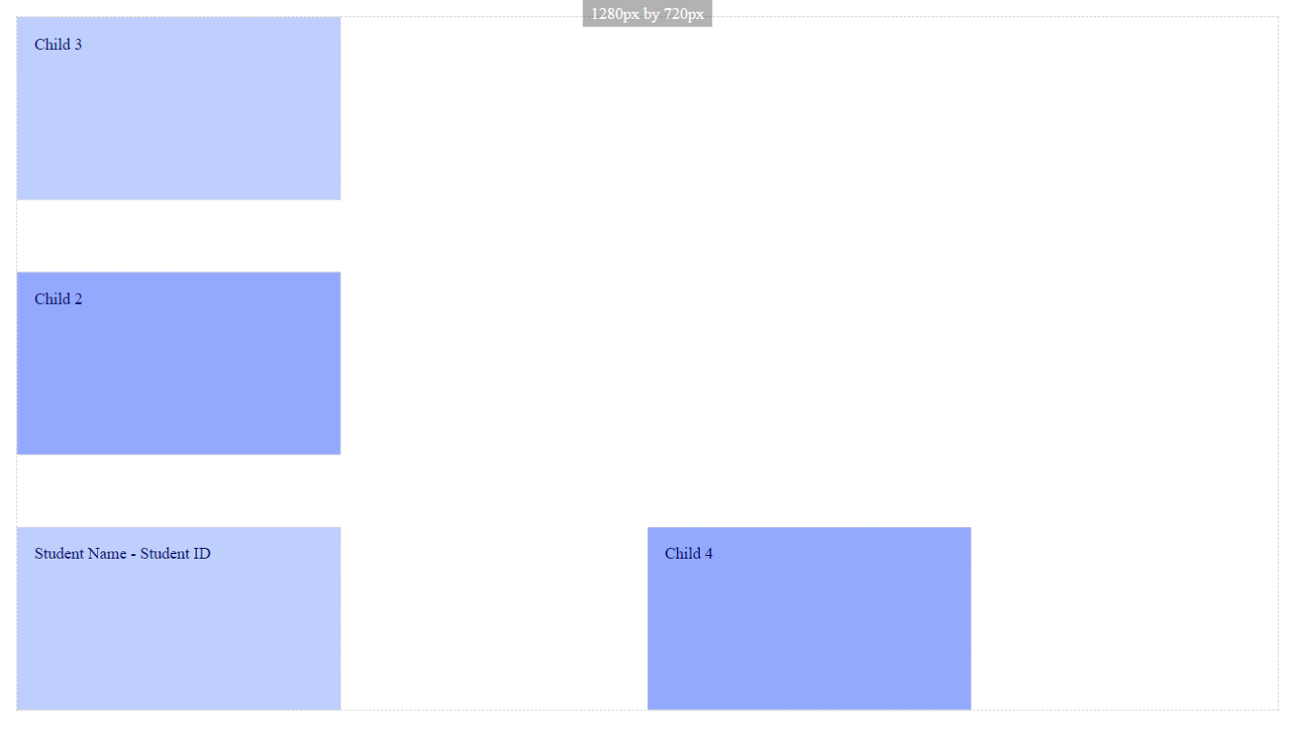

Paste a copy of your screenshot including your Student Name and Student ID (here)

Paste the style declaration you used to make your screenshot happen.

display:   
flex-flow:  
justify-content:

Screenshot 23

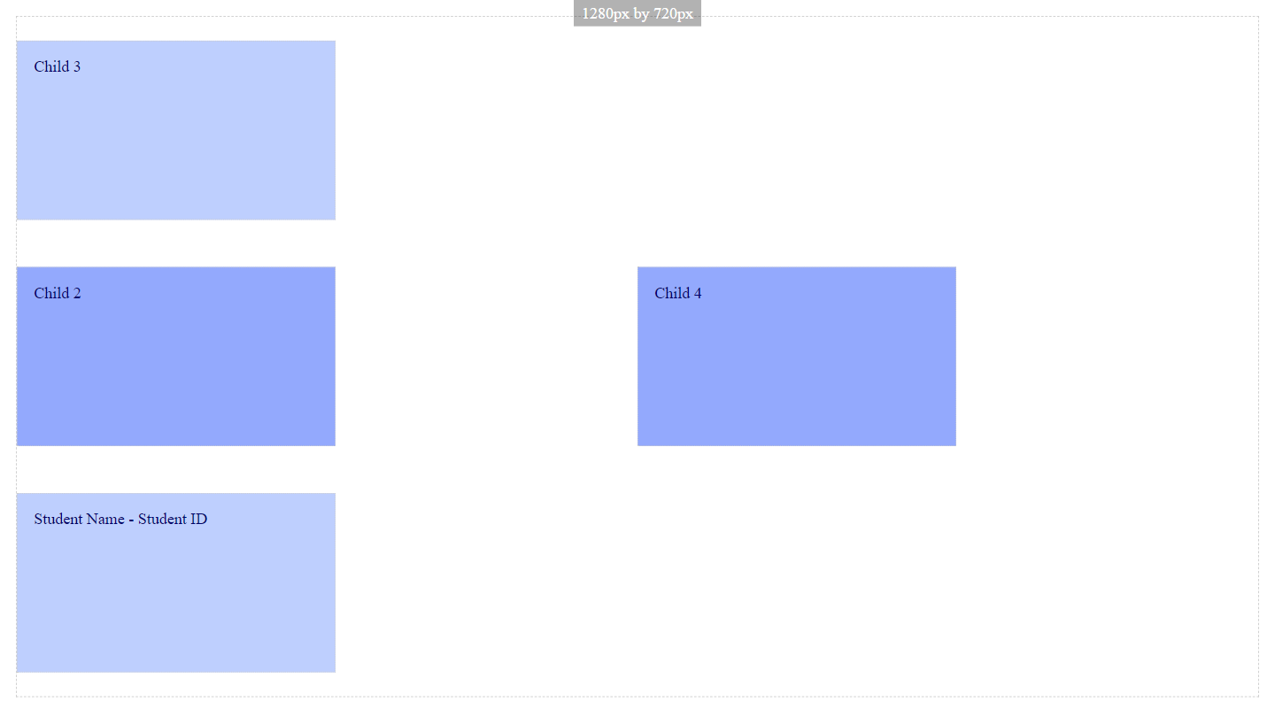

Paste a copy of your screenshot including your Student Name and Student ID (here)

Paste the style declaration you used to make your screenshot happen.

display:   
flex-flow:  
justify-content:

Screenshot 24

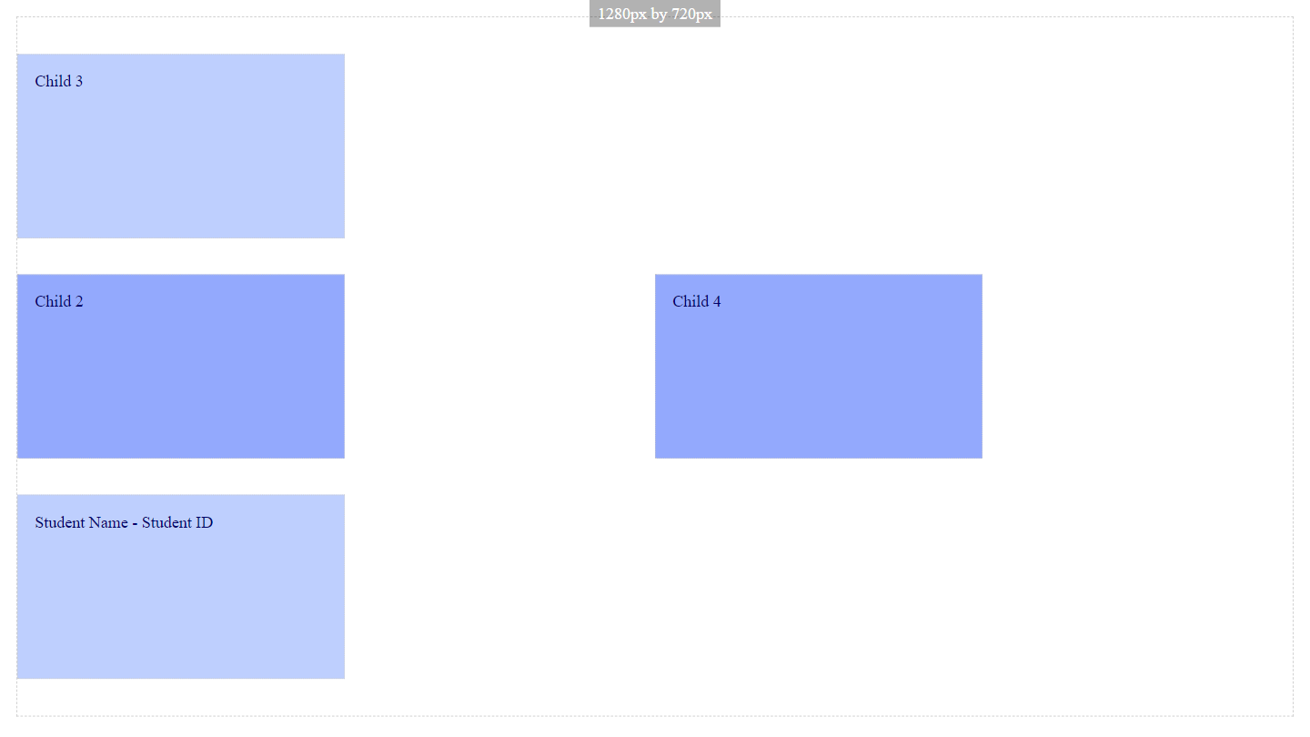

Paste a copy of your screenshot including your Student Name and Student ID (here)

Paste the style declaration you used to make your screenshot happen.

display:   
flex-flow:  
justify-content: